ORgSys

(Organization Recognition System)

Use Case Diagram

Submitted to:

Prof. Ma. Rowena C. Solamo

Faculty Member

Department of Computer Science

College of Engineering

University of the Philippines, Diliman

Submitted by:

GRANADA, Patrick James B.

MERCADO, Emir R.

YAP, Sharmaine A.

In partial fulfillment of Academic Requirements

Revision Control

*History Revision:*

| Revision Date | Person Responsible | Version  Number | Modification |
| --- | --- | --- | --- |
| 08/02/2013 | Emir Mercado | 1.0 | Initial Document |
| 08/22/2013 | Emir Mercado | 2.0 | Removed Criteria Maker  Added unit heads as actors |
| 09/20/2013 | Emir Mercado | 3.0 | Added University Registrar as an actor  Changed the system description  Changed the Organization actor description |
| 09/25/2013 | Emir Mercado | 4.0 | Renamed Use-Case 3.0 in the list of use cases  Updated association of the Online Storage actor  Edited the Online Storage actor description  Removed Use-Case 3.4 Maintain Requirements Checklist  Updated association of the Review Committee actor |
| 10/04/2013 | Emir Mercado | 5.0 | Reconstructed Use-Case Diagram  Removed University Registrar as an actor  Updated description of use-cases |
| 10/15/2013 | Emir Mercado  Sharmaine Yap | 6.0 | Added Use Case 5.0 View Requirements Checklist |

*System Name*: ORgSys (Organization Recognition System)

*Description*: The system's purpose is primarily to provide the Office of Student Affairs of UP Diliman's College of Engineering a means of evaluating the organizations during their application period for recognition for the whole school year. This system provides a way for the unit heads to upload the documents submitted by the organizations online. It will also serve as a venue for Associate Dean for Student Affairs and the Review Committee to provide the organizations with the list of required documents requirements for approval and to check if the member roster of the organization is valid.

*Use-Case Diagram*:

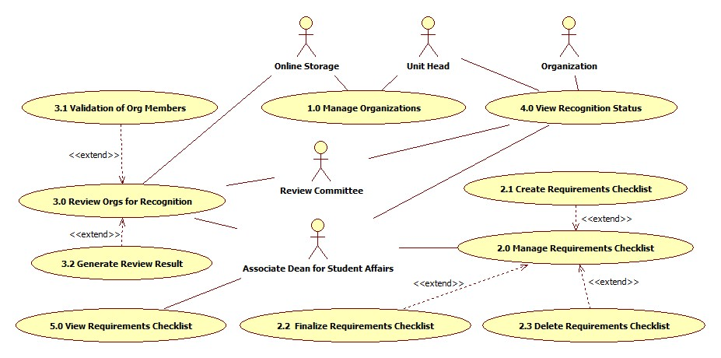

*List of Actors:*

| Actors | Description |
| --- | --- |
| Organization | The organizations are the ones who will submit the documents to the unit head for approval, for they are the ones who need recognition by the college. These organizations will be the student organizations housed by the College of Engineering of UP Diliman. |
| Online Storage | The online storage will be where the organizations upload their documents for submission. This online storage will only be available for the entire school year. |
| Associate Dean for Student Affairs | The Associate Dean for Student Affairs will have the most function in the system. He is the primary person that creates, updates, keeps, and deletes the organizations' records. |
| Review Committee | The Associate Dean for Student Affairs will assign a Review Committee to work with him/her on the checking o fthe submissions of the organizations. They will be the ones to evaluate the submissions of the organizations. |
| Unit Heads | The organizations must submit their documents to the unit heads in person. Once approved, the unit heads will then send the documents online through the system to be checked by the Associate Dean and the Review Committee. |

*List of Use-cases:*

| Use-Case | Description |
| --- | --- |
| Use-Case 1.0  Manage Organizations | When an organization submits their documents for renewal, their respective unit head's task is to manage their submission and account in the system. Once the org's documents are approved, their submission will be uploaded online for further approval. |
| Use-Case 2.0  Manage Requirements Checklist | The list of requirements that the organizations must submit will be created by the Associate Dean for Student Affairs. Once finalized, this will be the list to be followed by the organizations for their submissions. |
| Use-Case 3.0  Review Orgs for Recognition | Using the requirements checklist, the criteria created, and the data from the university registrar, the review committee together with the Associate Dean for Student Affairs will evaluate all the organizations. |
| Use Case 4.0  View Recognition Status | The organizations, unit heads, Associate Dean, and review committee can view the recognition status of the orgs. The information they can view depends on who made the request. |
| Use Case 5.0  View Requirements Checklist | The associate dean may be able to view the requirements checklist for reference purposes. |